Cell TRANSPORT (a STERNGRR process)
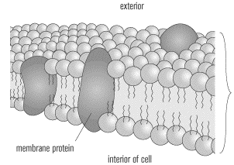

Materials move in/out of cells through the cell membrane:
_________________________ _____________________

Which other STERNGRR processes are related???
- Cell transport lets food in for ____________________
- Cell transport lets oxygen in for __________________
- Cell transport lets waste out for __________________

Passive Cell Transport | Active Cell Transport
Moves molecules from ____________ to ___________. | Moves molecules from ____________ to ___________.
Does not use _______________ to move molecules. | Does use _______________ to move molecules.
Moves molecules with _____________________ gradient. | Moves molecules against _____________________ gradient.
Molecules move until they reach EQUILIBRIUM
OSMOSIS:

Example:
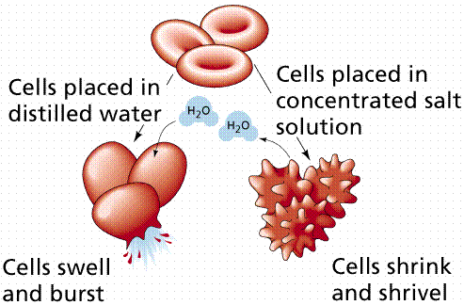
Osmosis is a
TYPE of diffusion!
DIFFUSION:

Example:
