EVOLUTION of Life
Evolution is……

Abiogenesis Prokaryotic Prokaryotic Prokaryotic Endosymbiont Multicellular
Anaerobic Photosynthetic Aerobic Hypothesis Life
Heterotrophic

Heterotroph Hypothesis

Disproven by : ___________________________
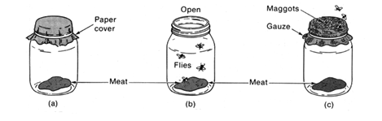
Disproven by : ___________________________
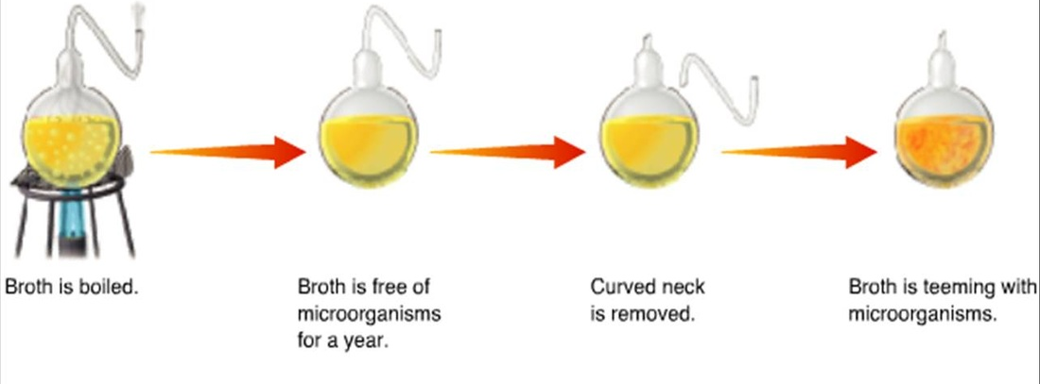

Variation is ___________________________________________________________________________________________

Organisms compete for _________________, __________________, _______________________, and avoidance of ______________________.

Evolution still happens!

What causes antiobiotic resistance?
HOW does evolution occur?

NATURAL SELECTION
____________________________________________________________

Adaptation:

Proposed by _____________

4 REQUIREMENTS
1)______________________

2)______________________

3)______________________

4)________________________

Individuals DON’T evolve, ________________________ do!
- Requires a change in the ________________________
- _____________________ is the raw material for change
  - Can be selected ____________.
  - Can be selected ____________.
- 3 selection mechanisms:
__________ __________ ___________

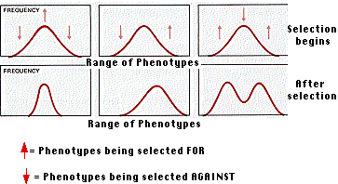

Speciation: ______________________________

Evidence for Evolution:
