Cellular Respiration

Mitochondria

Aerobic Respiration

Words:
ATP

Anaerobic Respiration

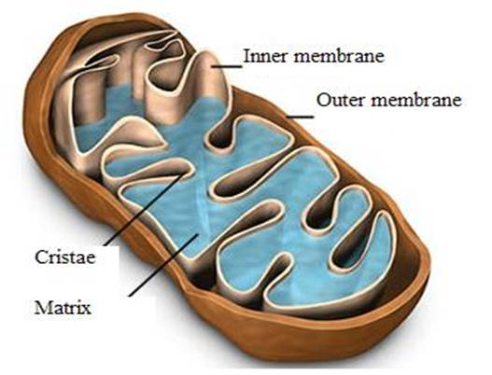

Aerobic:

Chemical Formula:

ANAEROBIC VS. AEROBIC

- Ex.

