The Cell Theory: PROKARYOTIC CELLS:
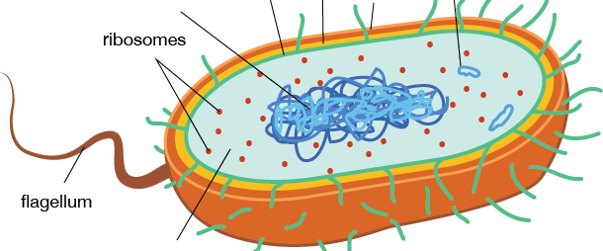
Prokaryotic cell ONLY:
ALL cells have:
1.
2.
3.
4.

EUKARYOTIC CELLS:
ANIMAL CELL PLANT CELL
Organelles in BOTH:
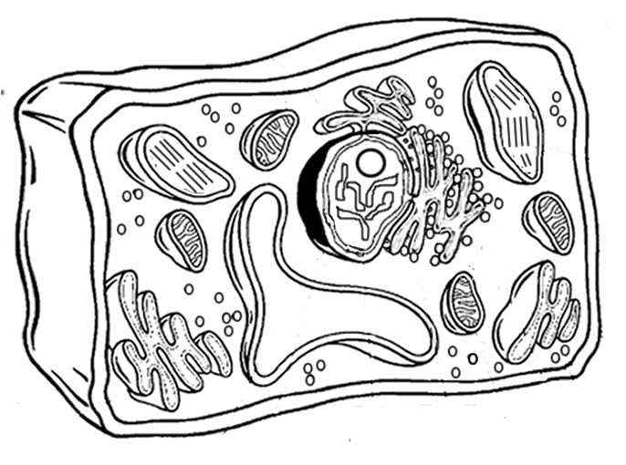
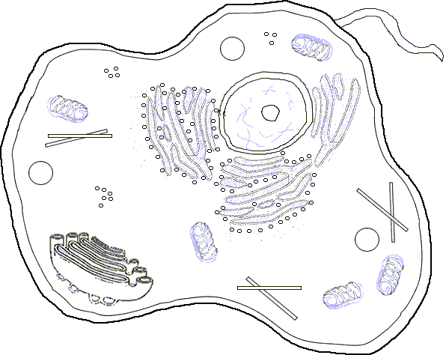

Animal cell ONLY:
Remember….FORM RELATES TO FUNCTION (Job determines shape)
Plant cell ONLY:

Organelle | Picture | Function | Animal, Plant or Both
CELL WALL
CELL MEMBRANE
NUCLEUS
RIBOSOME
MITOCHONDRIA
VACUOLE
CHLOROPLAST
CENTRIOLES

