Cell Transport
Cell Membrane

Selectively Permeable

2 Types of Cell Transport
- Passive Transport
Examples:

Diffusion

Osmosis

- Active Transport

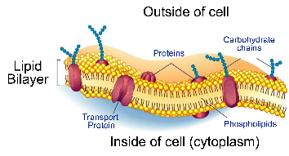

Ex.

Equilibrium-

Concentration Gradient

Carrier Protein

